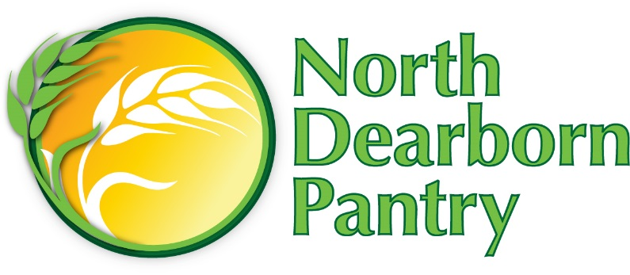

May 17th, 2016
Dear Sunman-Dearborn Schools,
With summer rapidly approaching, we realize there will be many families scrambling to replace the lunches their children have been receiving at school. We would love families in our northern Dearborn County service area to feel welcome at the North Dearborn Pantry.
We are open on:
Sunday from 5:30pm to 8pm
Monday from 9am to noon
Tuesday from 5:30pm to 8pm
Saturday from 9am to noon
Patrons of the Pantry are residents of North Dearborn County - Jackson, Kelso, Logan, Harrison, York and Miller Townships. Please let parents know to bring proof of residence when they visit the Pantry. Snack packs will be available once school lets out.

Thank you and have a blessed summer,

Barb Lyness
Director, North Dearborn Pantry, Inc.

